Middle East and North Africa Solidarity Day at Occupy Boston
Sunday December 4, 4-6 pm

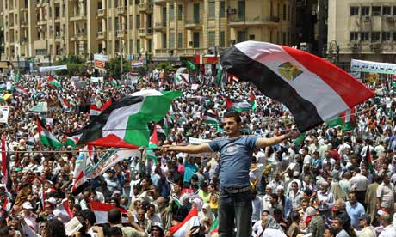
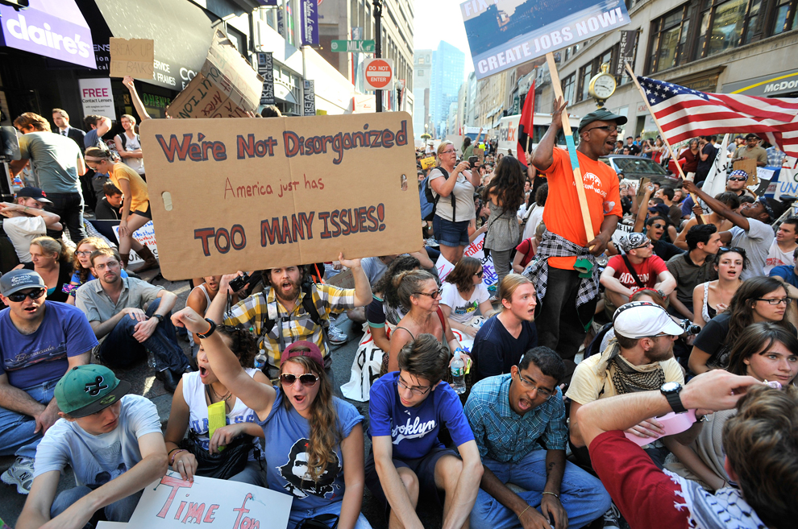

In the past year, there have been uprisings across the Middle East and North Africa in countries such as Tunisia, Egypt, Syria, and Yemen. The uprisings have inspired people across the world, including the Occupy movement in the US. At the same time, when questioned about US-made tear gas being used to repress protestors in Egypt, a US government spokesman said “this tear gas is approved for export to many countries around the world. It’s used by police forces in many countries around the world including our own.”

What is going on in countries that are US allies like Egypt, Bahrain, and Tunisia?
What is going on in regimes that are not US allies, such as Syria and Iran?
How does Israel/Palestine fit into the regional context?
What are the economic interests behind US and European intervention in the region?

Please join us on Sunday December 4 from 4-6pm in Dewey Square (Occupy Boston main stage) next to South Station for a public discussion on solidarity with the movements of the 99% in the Middle East and North Africa!

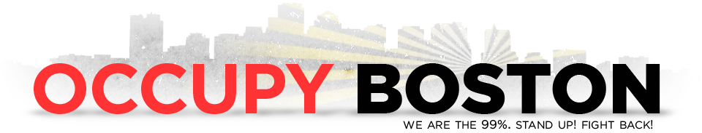
Web: https://www.facebook.com/events/254237974629348/
Email: bdubkwob@gmail.com or serene.heart1@gmail.com
Phone: (607)280-1627

